**5G vs. 5 GHz Wi-Fi**

What's the difference between 5 GHz Wi-Fi and 5G?

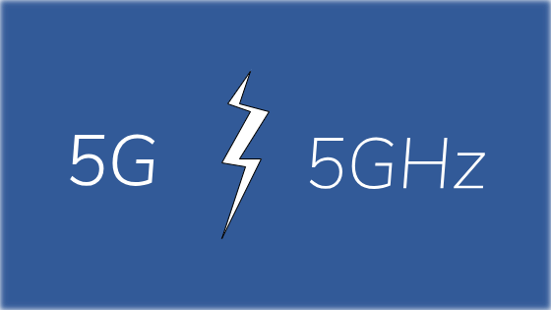

Are 5G and 5 GHz Wi-Fi the same? No, but technically they have a few things in common. First, both of these terms revolve around wireless technology.

To put it bluntly, 5G is a new standard for mobile phones that other mobile phones can take advantage of, and simply refer to improvements from the previous level of a mobile network called 4G.

5 GHz refers to the part of the radio used by Wi-Fi devices. Most people use this term only when connecting to other Wi-Fi networks or when comparing 5 GHz Wi-Fi with 2.4 GHz Wi-Fi.

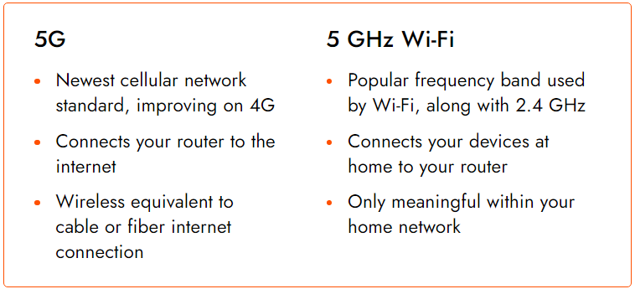

**5G: The Newest Version of the Mobile Network**

If mobile devices — such as your smartphone or laptop computer — are not on Wi-Fi but are still connected to the Internet, they can do so with the mobile network operator's data service (MNO). 5G is the latest technology that aims to provide the fastest connection to those devices.

Widely used, 4G is still the fastest mobile technology used today, but as soon as 5G goes off and more 5G phones are released, 5G will provide more improvements than 4G, which will allow 5G to transform many industries. be better.

Verizon, AT&T, T-Mobile, and Sprint are just a few examples of US MNOs operating in 5G networks. This very new level of mobile phones is currently in the process of reaching many other countries around the world, too.

**5 GHz: Wi-Fi Frequency Band**



Devices connected to the Wi-Fi network can transmit data to two frequency bands, depending on the route: 5 GHz and 2.4 GHz. Similar to 5G mobile networks faster than 4G because they operate at higher frequencies, 5 GHz Wi-Fi is usually faster than 2.4 GHz for the same reason.

*The 5 GHz also has the disadvantages (like 5G) of not being able to properly broadcast on the walls and having a shorter Wi-Fi range than the lower band of 2.4 GHz.*

However, 5 GHz is only used within the Wi-Fi context. That is, if you are in a home or business where the wireless router or access point supports 5 GHz, devices can connect to the same frequency band instead of 2.4 GHz.

5 GHz is an option for routers to enable faster transmission speeds and help reduce congestion and disruption by allowing the network to operate on more channels than supported by 2.4 GHz. Most modern routers are dual-band routers, which means they operate on both 2.4 GHz and 5 GHz frequency bands.

**What About ‘5G Wi-Fi Routers’?**

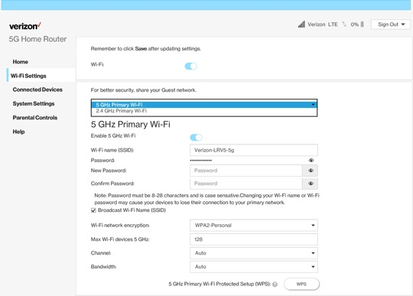

From now on, if you see a Wi-Fi network with “5G” named after it, it usually does not refer to gigahertz frequencies (5 GHz). The person who chose that Wi-Fi hotspot probably did so to separate it from a 2.4 GHz network with two bands capable of streaming.

A two-band router may have both types of network-enabled so that older devices supporting only 2.4 GHz can connect to the network. At the same time, new devices can use 5 GHz on the same route to use new technologies.

In the past, when 5G mobiles were still years away, it was no surprise to call a 5GHz Wi-Fi router “5G router” because it could not be mistaken for an internet connection via a 5G mobile connection. Now, however, with 5G mobile carriers right around the corner, you can see how confusing this is.

As 5G networks become more sophisticated and may replace broadband at home, the routers used to place our devices online over 5G mobiles will most probably be appertained to as 5G routers, meaning they connect your home network to the internet via a 5G mobile network. Within your home network, your smart devices will still have the option of connecting the routes to both 2.4 GHz and 5 GHz frequency bands.